Practical - 7

**Question 1**

1. Create a table student with following attributes:

|  |  |  |
| --- | --- | --- |
| Roll No | Number | 6 |
| Name | varchar | 15 |
| City | varchar | 12 |
| Pincode | varchar | 8 |
| Age | Number | 2 |

**Solution -:**

**CREATE TABLE Student (**

**RollNo NUMBER(6) PRIMARY KEY,**

**Name VARCHAR2(15) NOT NULL,**

**City VARCHAR2(12),**

**Pincode VARCHAR2(8),**

**Age NUMBER(2)**

**);**

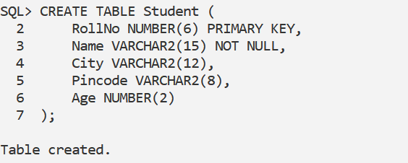

1. **Display the structure of table**

**DESC Student;**

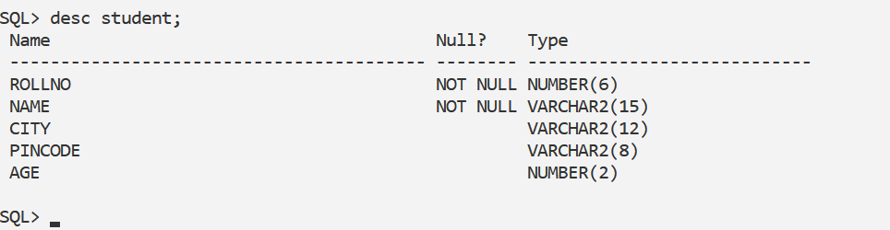

1. **Insert the following data into the table (Enter as it is)**

|  |  |  |  |  |
| --- | --- | --- | --- | --- |
| **Roll No** | **Name** | **City** | **Pincode** | **Age** |
| 1 | Amit | Delhi | 214213 | 21 |
| 2 | Kumar | Bombay |  | 25 |
| 3 | Kshitij | Madras | 110101 | 16 |
| 4 | Puneet | Calcutta | 110107 | 18 |
| 5 | Rohit | Delhi | 502207 | 19 |
| 6 | Karnal | Dehradun |  | 28 |
| 7 | Shweta | Dehradun | 98102 | 23 |
| 8 | Mohit | Bombay | 12434 | 22 |
| 9 | Pankaj | Bombay |  | 17 |
| 10 | Parul | Delhi | 76312 | 24 |
| 11 | Rohit | Baroda | 12131 | 29 |

**Solution -:**

INSERT INTO Student (RollNo, Name, City, Pincode, Age) VALUES (1, 'Amit', 'Delhi', '214213', 21);

INSERT INTO Student (RollNo, Name, City, Pincode, Age) VALUES (2, 'Kumar', 'Bombay', NULL, 25);

INSERT INTO Student (RollNo, Name, City, Pincode, Age) VALUES (3, 'Kshitij', 'Madras', '110101', 16);

INSERT INTO Student (RollNo, Name, City, Pincode, Age) VALUES (4, 'Puneet', 'Calcutta', '110107', 18);

INSERT INTO Student (RollNo, Name, City, Pincode, Age) VALUES (5, 'Rohit', 'Delhi', '502207', 19);

INSERT INTO Student (RollNo, Name, City, Pincode, Age) VALUES (6, 'Karnal', 'Dehradun', NULL, 28);

INSERT INTO Student (RollNo, Name, City, Pincode, Age) VALUES (7, 'Shweta', 'Dehradun', '98102', 23);

INSERT INTO Student (RollNo, Name, City, Pincode, Age) VALUES (8, 'Mohit', 'Bombay', '12434', 22);

INSERT INTO Student (RollNo, Name, City, Pincode, Age) VALUES (9, 'Pankaj', 'Bombay', NULL, 17);

INSERT INTO Student (RollNo, Name, City, Pincode, Age) VALUES (10, 'Parul', 'dELhi', '76312', 24);

INSERT INTO Student (RollNo, Name, City, Pincode, Age) VALUES (11, 'Rohit', 'Baroda', '12131', 29);

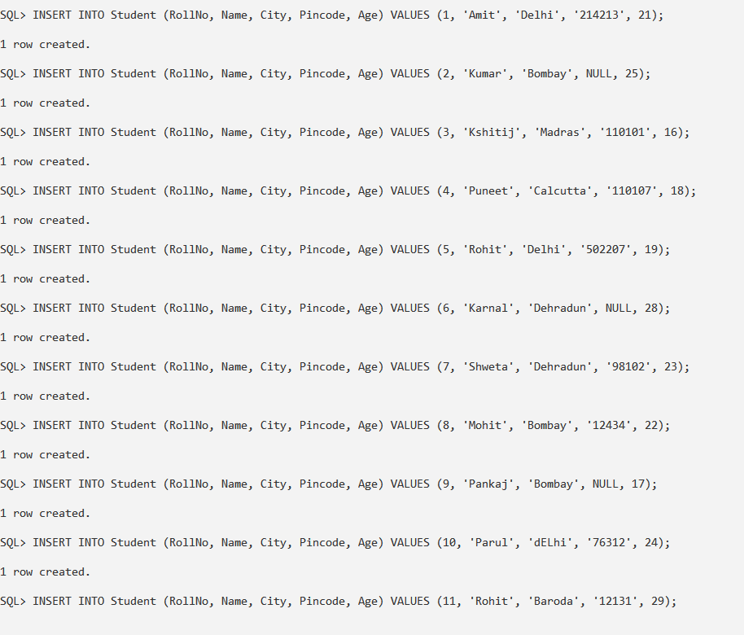

1. **Show all records**

SELECT * FROM Student;

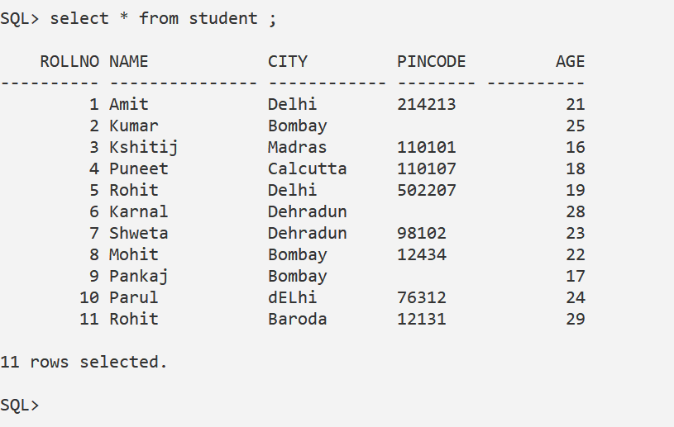

1. **Show names of all students living in Delhi.**

SELECT Name FROM Student WHERE City = 'Delhi';

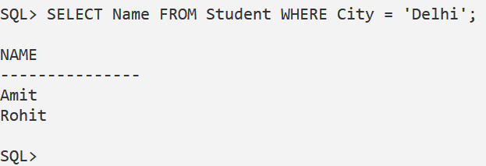

1. Insert the following data further into the same table.

|  |  |  |  |  |
| --- | --- | --- | --- | --- |
| 2 | Gaurav | Rampur | 312125 |  |
|  | Manish |  | 314136 |  |
| 14 | Aviral |  | 319143 | 29 |
| 15 |  | Gwaliar | 313149 | 25 |

**Solution -:**

-- Inserting a new record with missing Age

INSERT INTO Student (RollNo, Name, City, Pincode, Age) VALUES (2, 'Gaurav', 'Rampur', '312125', NULL);

-- Inserting a new record with missing RollNo and City

INSERT INTO Student (Name, Pincode, Age) VALUES ('Manish', '314136', NULL);

-- Inserting a new record with missing City

INSERT INTO Student (RollNo, Name, Pincode, Age) VALUES (14, 'Aviral', '319143', 29);

-- Inserting a new record with missing Name

INSERT INTO Student (RollNo, City, Pincode, Age) VALUES (15, 'Gwaliar', '313149', 25);

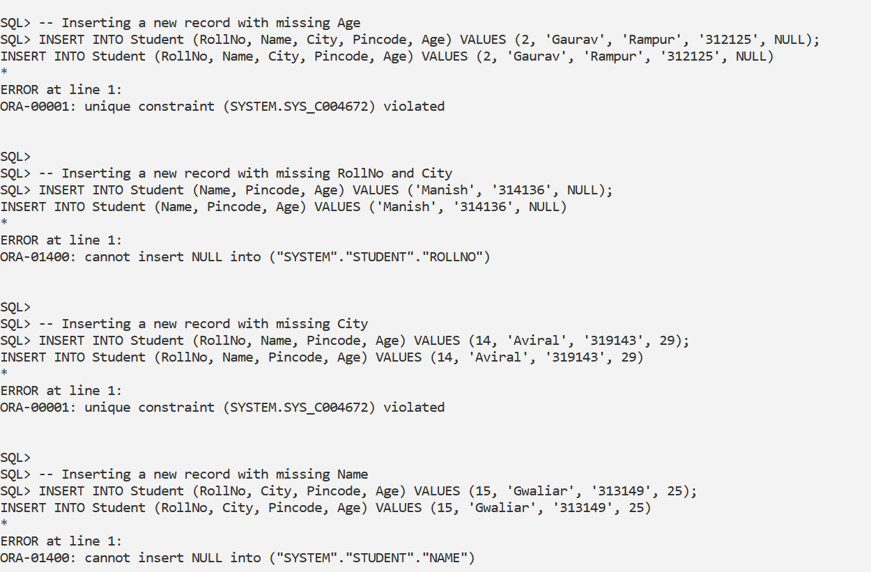

**i. Assign Roll No. “13” to Manish**

UPDATE Student SET RollNo = 13 WHERE Name = 'Manish';

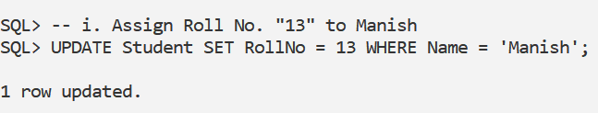

**ii. Assign the name “Abhijeet” to Roll No. 15**

UPDATE Student SET Name = 'Abhijeet' WHERE RollNo = 15;

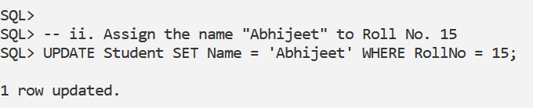

**iii. Set the cities of Roll No. 13 & 14 to “Meerut”**

UPDATE Student SET City = 'Meerut' WHERE RollNo IN (13, 14);

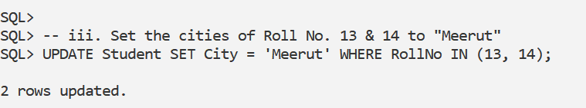

**iv. Increase all age by 3 years**

UPDATE Student SET Age = Age + 3;

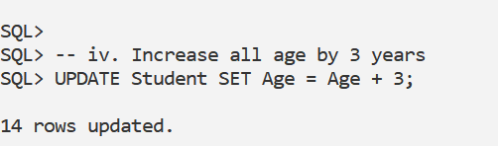

**v. Set the age of all students living in Meerut to “25”**

UPDATE Student SET Age = 25 WHERE City = 'Meerut';

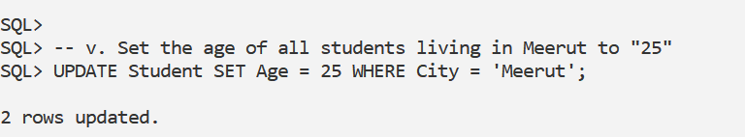

**vi. Add a new column named “Balance” (NUMBER(6)) to the student table**

ALTER TABLE Student ADD Balance NUMBER(6);



**vii. Set the balance of all students to Rs. 20,000/-**

UPDATE Student SET Balance = 20000;

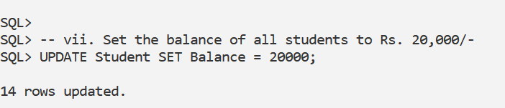

**viii. Increase the balance by Rs. 500/- for all Bombay & Delhi students**

UPDATE Student SET Balance = Balance + 500 WHERE City IN ('Bombay', 'Delhi');

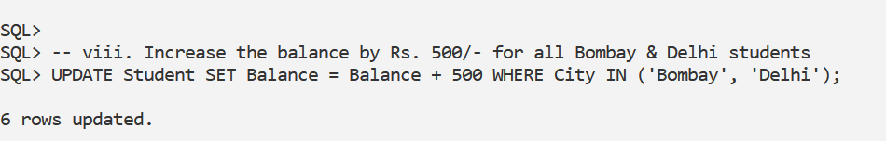

**ix. Show the total balance due from all students**

SELECT SUM(Balance) AS Total_Balance FROM Student;

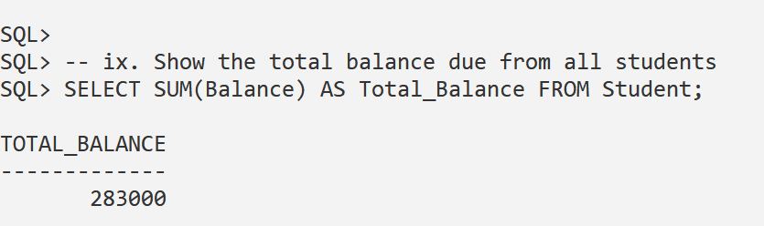

**x. Show the maximum balance**

SELECT MAX(Balance) AS Max_Balance FROM Student;

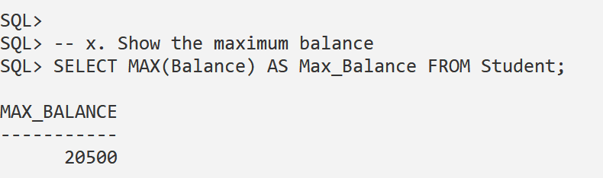

**xi. Increase the size of “Balance” column to 10**

ALTER TABLE Student MODIFY Balance NUMBER(10);

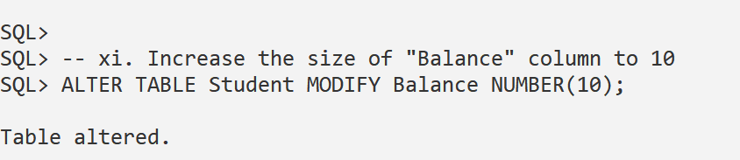

**xii. Reduce the size of “City” column to 10**

ALTER TABLE Student MODIFY City VARCHAR2(10);

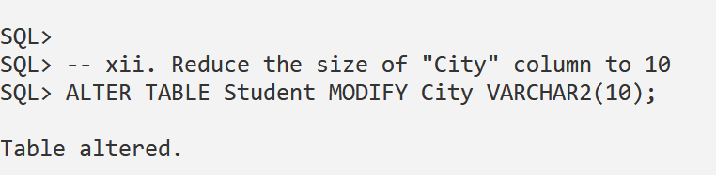

**xiii. Create a new table “Student2” as a copy of Student (with all records)**

CREATE TABLE Student2 AS SELECT * FROM Student;

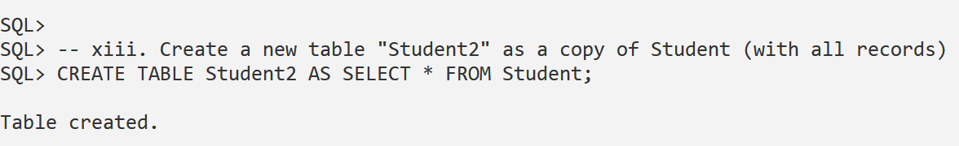

**xiv. Show the structure of Student2**

DESC Student2;

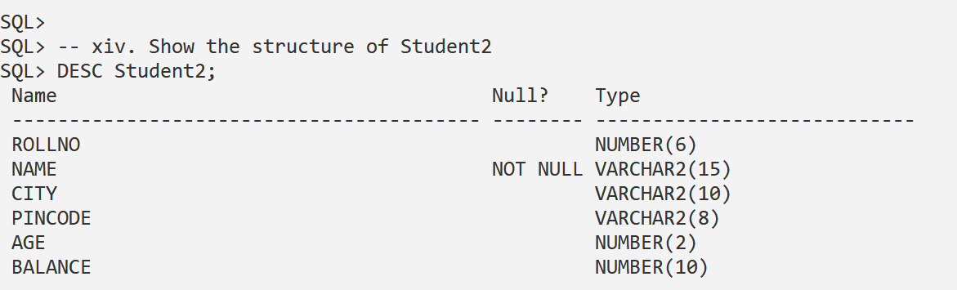

**xv. Delete records of students from Student2 who are 25 years or older**

DELETE FROM Student2 WHERE Age >= 25;

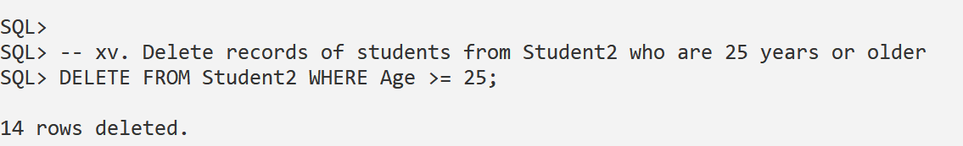

**xvi. Show all records of Student2 table**

SELECT * FROM Student2;

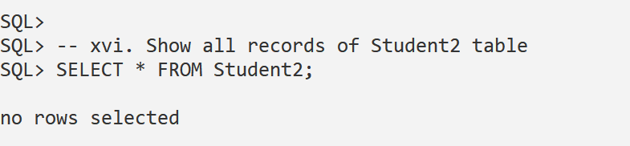

**xvii. Rename the Student2 table to “NewStudent”**

ALTER TABLE Student2 RENAME TO NewStudent;

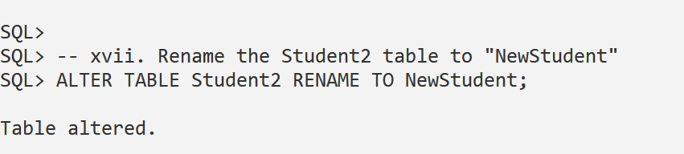

**xviii. Delete all records from “NewStudent”**

DELETE FROM NewStudent;

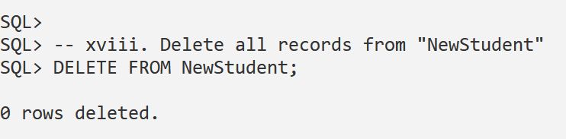

**xix. Drop the “NewStudent” table**

DROP TABLE NewStudent;

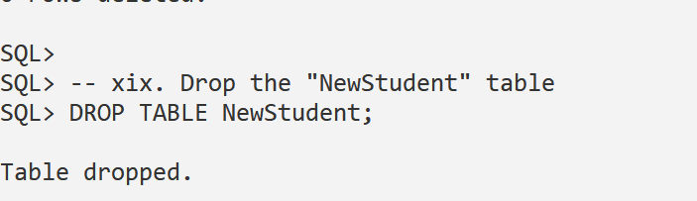

**xx. Create the “NewStudent” table similar to Student but without copying records**

CREATE TABLE NewStudent AS SELECT * FROM Student WHERE 1=0;

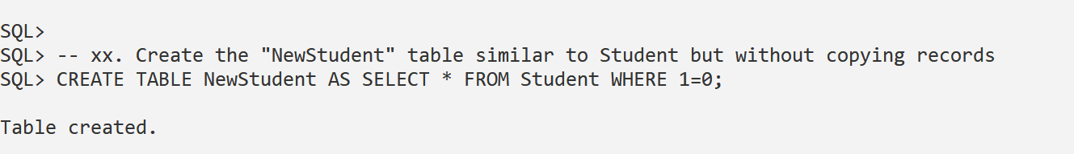

**xxi. Create a new table “BCA” with only three columns (Roll No, Name, Balance) and copy data from Student**

CREATE TABLE BCA AS SELECT RollNo, Name, Balance FROM Student;

